CIS 525 WT HOMEWORK 5

CREATING WEBSITES USING VSC

Likhitha Suggala,

42015235

**WEBSITE FILES:** Uploaded along with this document.

**WEBSITE SUMMARY:**

This is an advertising website where I have decided to feature my aunt's business in three web pages that correspond to her business's categories. I reasoned that she and others would benefit from learning more about her services on this website, making it simpler for them to get in touch with her. To draw the attention of the user, I used many styles and backgrounds while building this website using HTML and CSS documentation. To make the UI adaptable and make it simple to move from one page to another, I used media, hyperlinks, and buttons. I completed the documentation using Microsoft Notepad++ as a text editor.

**WEBSITE NAVIGATION:**

1. This is the home page of the website, and it takes to the next webpages upon clicking the links displayed on the left corner of the page.

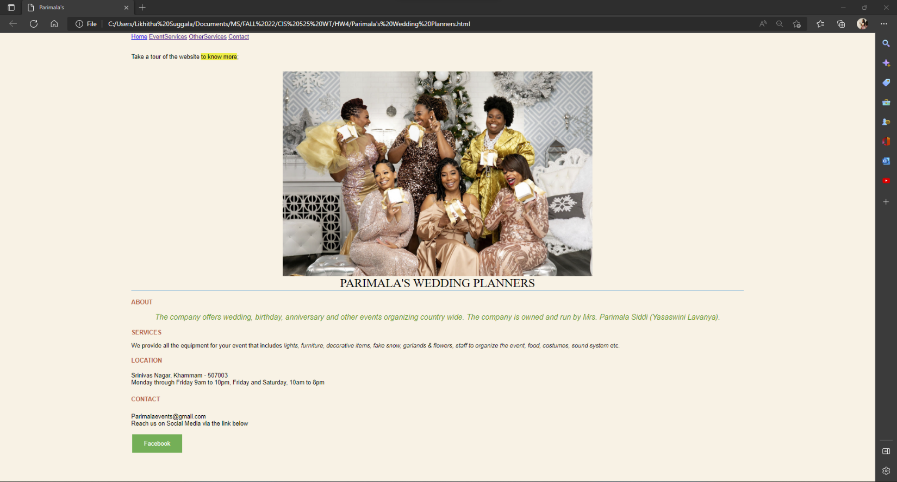

2. This is the second page of the website, and it has an external link displayed at the bottom.

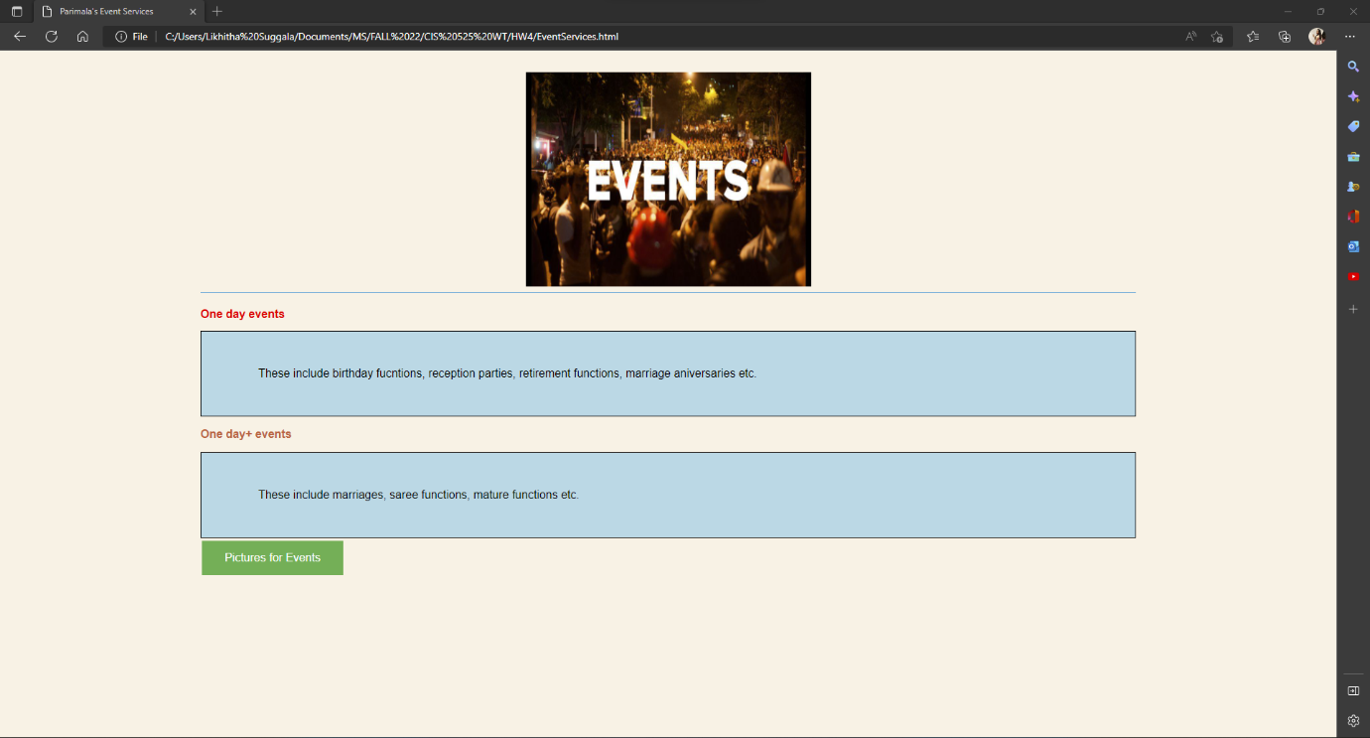

3. This is the third page of the website.

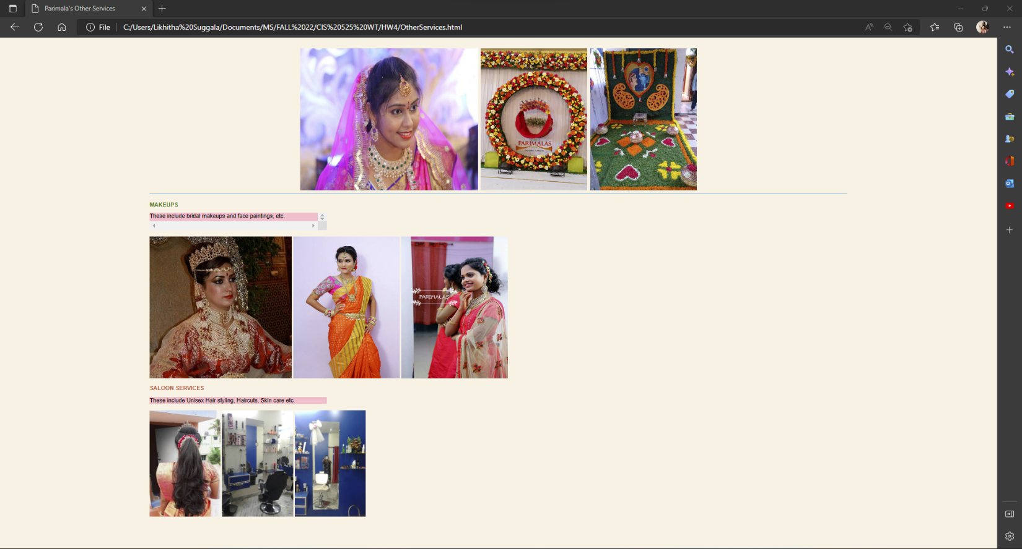

4. This is the fourth webpage

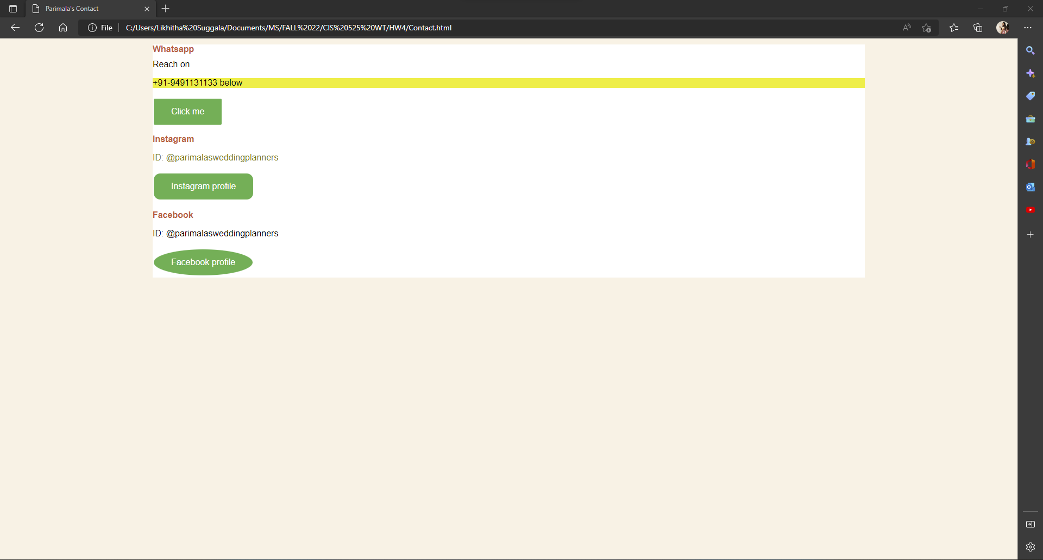

**WEBSITE ISSUES:**

It took me hours to finish because I had never used HTML and CSS before to make a website. After using Google Sites and running into serious interface issues, I realized that using HTML and CSS wasn't as simple as I had first assumed it would be. I used Notepad++ & VS code to write the code properly indented and to finish the documentation. I did my best to convert the hyperlinks to buttons, however I was unable to alter the colors of the buttons on the same website. When I added the external CSS file to the HTML document, there seemed to be a problem because the changes did not show up. Overriding the html elements and tags was difficult for me.

**FUTURE PLANS TO IMPLEMENT:**

I'm curious to learn more about the creation of websites. I need to work on adding external links and improving page navigation. The home page needs a header and footer that navigates to and follows the other webpages. I need to practice more with seeing websites or webpages in various layouts. Inline vs. block scripting must also be changed. I also need to familiarize myself with overflow attribute. I need to work on placing buttons, hyperlinks, and media flawlessly so that they perfectly align with the text and webpage. I also need to work on Form validation and linking forms. I want to use a few extra extensions and applications to make the website look more professional rather than more like a blogger's page. In addition, the alignment of the image needs to be changed.

HOMEWORK 4 SUMMARY:

As I have mentioned, I have never built a website using HTML and CSS documentation. I'm glad I now know how to build websites using a third platform besides WordPress and Google Sites. Even though I don't perform any website building, I find this coursework to be interesting and am interested in learning more. The practice labs, quizzes, and presentation slides are all part of this homework, along with the media links that were provided with the assignments. The website I built still requires improvement, and to code properly, I need to brush up on my CSS knowledge. I can't wait to finish my remaining tests and homework. The presentation slides included an overview of web technologies and defined key terms associated with the web.

CSS VALIDATION

All the five HTML/CSS files are validated using CSS validator Jigsaw.

